COINS-Eur-Thrace-Chersonesos

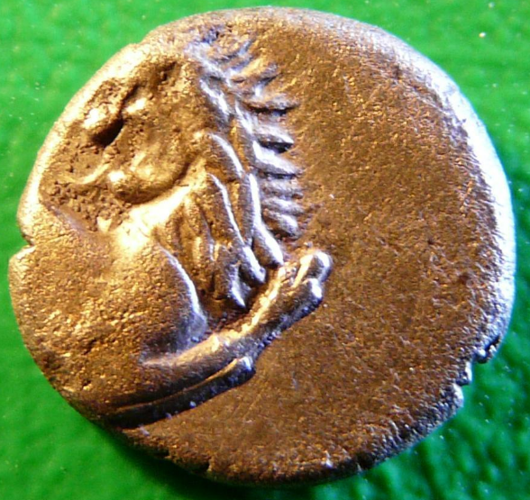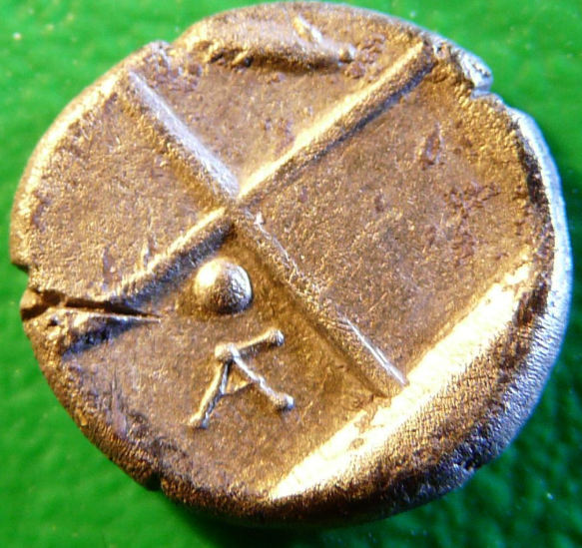

Sear 1603

400-350 BCE AR Hemidrachm, ca. 2-4 gm

Forepart of lion r., looking back, paws raised. R. Quadripartite incuse square, the alternate depressions deeper and each containing a pellet. BMC 3, p. 183, 8,9.

This specimen has an ear of corn instead of a pellet in the opposing incuse square and in the pellet incuse square is the mint mark .